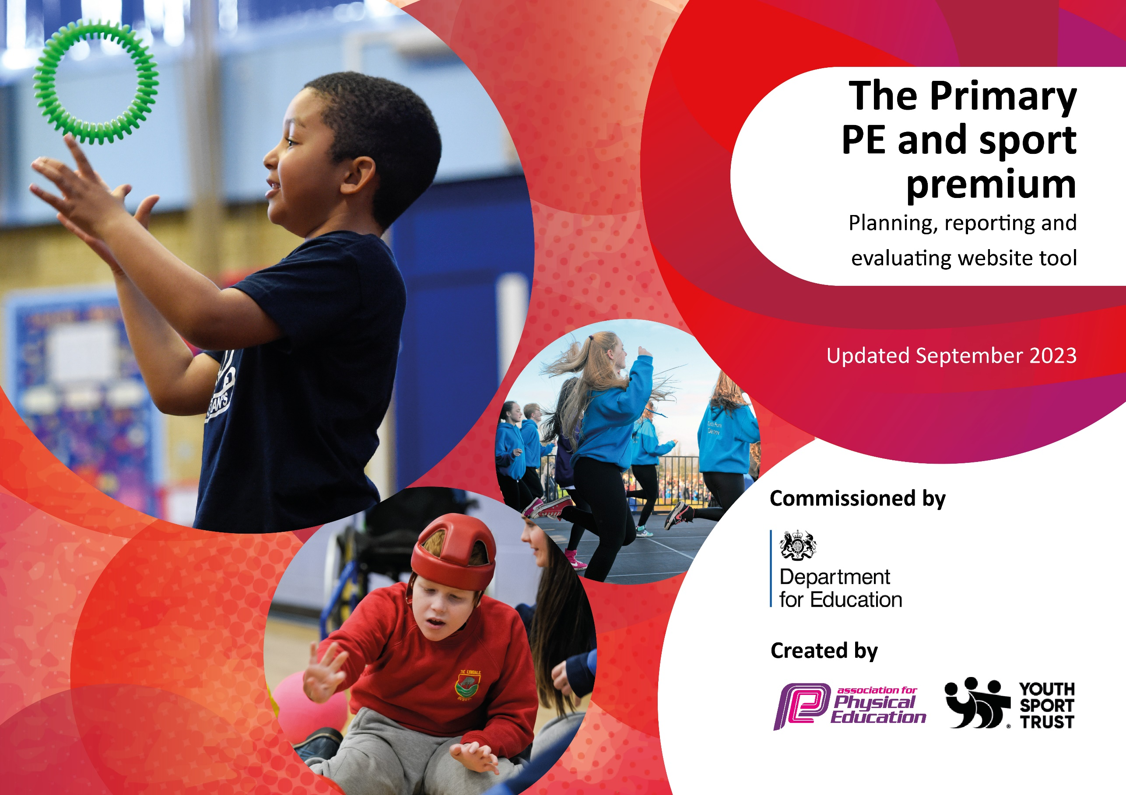

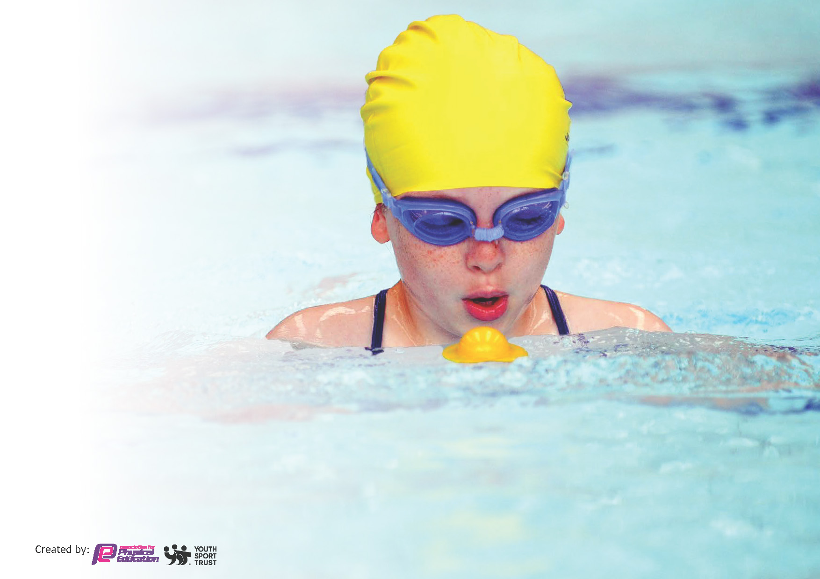
This template can be used for multiple purposes:
by:
- It enables schools to effectively plan their use of the Primary PE and sport premium
- It helps schools to meet the requirements (as set out in guidance) to publish information on their Primary PE and sport premium
- It will be an effective document to support Ofsted inspections enabling schools to evidence progress in Physical Education (PE) and evidence swimming attainment, which forms part of the PE National Curriculum. We would recommend schools consider
the Intent, Implementation, and Impact of any spend, as examined within the Education Inspection Framework.

It is important that your grant is used effectively and based on school need.

Schools must use the funding to make additional and sustainable
improvements to the quality of the PE, School Sport and Physical Activity (PESSPA)
they offer. This means that you should use the Primary PE and sport premium to:

- Build capacity and capability within the school to ensure that improvements made now will benefit pupils joining the school in future years
- Develop or add to the PESSPA activities that your school already offers.

The Primary PE and sport premium should not be used to fund capital spend projects; the school’s core budget should fund these. Further detail on capital expenditure can be found in the updated Primary PE and sport premium guidance.

The Primary PE and sport premium guidance, outlines 5 key priorities that funding should be used towards. It is not

necessary that spending has to meet all the key priorities, you should select the priorities that you aim to use any funding towards.

Although completing this template is not a requirement for schools, schools are required to publish details of how they spend this funding. Schools must also outline what the impact this funding has had on pupils’ PE and sport participation and attainment and how any spending will be sustainable in the future. All funding must be spent by 31st July 2024.

The Department for Education has worked closely with the Association for Physical Education (afPE) and the Youth Sport Trust (YST) to develop this template and encourages schools to use it. This template is an effective way of meeting the reporting requirements of the Primary PE and sport premium.

Key priorities and Planning
This planning template will allow schools to accurately plan their spending.

Action – what are you planning to do | Who does this action impact? | Key indicator to meet | Impacts and how sustainability will be achieved? | Cost linked to the action
Refine and embed the new PE curriculum | All teaching staff as they will be leading and embedding the curriculum, ensuring all children are provided with 2hr PE per week.  Teaching staff will have access to a platform with a large variety of resources that will enhance PE lessons.  Teaching staff will have access to high quality CPD and support build into the curriculum.  PE leads to monitor and evaluate the curriculum and refine as require. Then feed back to SLT.  All children across the school as they will be getting high quality PE provision. | Key indicator 1, 2, 3 | Teachers will more confident to deliver effective PE supporting pupils to undertake extra activities inside and outside of school, as a result improved % of pupil’s attainment in PE.  All children have access to continued high quality PE provision.  All children have a variety of opportunities to engage and develop their skills in a wide variety of sports and physical activities.  All Children have opportunities to develop previous learning and build on the skills | £600 for the Get Set for PE platform Access.  £1200 - Membership to Manchester schools PE Association.
Extend offering of extra curriculum sports activities after school | Key Stage 1 and 2 children will have access to quality afterschool physical activity every week.  TA’s – supporting external coaches.  External coaches  Parental questionnaires sent for children to decide what extracurricular activities they would like. | Key indicator 2,3,4 | More pupils meeting their daily physical activity goal  KS1 and 2 children provided with a variety of different opportunities and encouraged to take part in PE and Sport Activities outside of the curriculum. | £7835 costs for additional coaches to support extra-curricular activities.  £700 Specialist tennis coach to provide extracurricular sessions
Provide specialist training for staff to enhance their skills to deliver quality first PE lessons.  - With school curriculum  - PE courses | Teachers receiving specialist CPD.  Children- they will benefit from the enhanced skills of staff who are well trained. | Key indicator 1 | Class teachers are more confident to deliver effective PE lessons, as a result improved % of pupil’s attainment in PE and children will be more engage. | £300 CPD external CPD for KS1 and 2 Staff  £1050 for specialist tennis coach.  Link to get set for PE platform cost.
Continue and extend the play leader provision – supporting more active lunch times for all children | Year 6 children, will lead and organized physical activities for children across the school during lunchtimes.  All children across the school will have opportunity to be involved in the activities during lunch time.  Year 5 children will be trained to become the next play leaders. | Key indicators 2,3,4 | Children across the school will be more active at break and lunch times. They will have opportunity to engage in variety of organized activities outside of the curriculum.  Improved physical activity and fitness levels for all children across the school.  Increased levels of engagement and enthusiasm for physical activity.  Children more aware of the importance and fun of daily activity.  Improved gross and fine motors skills for EYFS children. | £ 1650 to enhance and extend resources for play leaders
Extend and enhance the variety of resources available for physical activities across the school | All children will benefit from a wider variety of resources to choose from and will greater opportunity to practice and develop skills, in curriculum sessions, extracurricular sessions and competitions. | Key indicator 3,4 | Increased engagement and enjoyment during PE lessons for all children, Inc. SEND.  Children are gaining experiences of a wider variety of sport equipment raising their skill levels, their attitude and their views towards PE | £ 2745 to extend and enhance resources that are available for children throughout the school for physical activity and outdoor adventure.
Continue to arrange and provide opportunities for children to take part in competitive sporting. | All children will be engaged in competitive sports at different points in the year.  Teaching staff will arrange internal competitions  PE Leads will arrange external competitions against other schools. | Key indicator 4, 5 | Enjoyment and competitiveness of the children.  Evidence of wider social skills shown in other areas of social life through competition e.g. manners, teamwork, competitiveness.  Children will have access to a wider variety of sports as they will be able to access different locations | £ 500 to provide transport for children to attend external activities.  £100 – rewards for competition
To develop the provision for children with SEND and reluctant pupils | Purchase resources to extend our current physical sensory circuits provision.  CPD for staff with occupational therapist,  in the delivery of Sensory circuits.  Set up system for SEND and Reluctant pupils to be  involved in every lesson, through use of lanyard activities.  Workshops and theme days to break down barriers and prompt growth mindset when difficulties arise. | Key indicator 4 | Reluctant learners and children with SEND will have opportunity to engage in lessons specifically designed to meet their needs.  They will be involved in every lesson moving at their own pace and level of development.  Children’s attitude towards PE and sports will be supported to provide children with more positive views.  All children will understand the different barriers to learning and will be supported to develop their, independence and perseverance | £1000 – contribution to fund (resources and training for staff with OT)  £550 theme days

Key achievements 2023-2024
This template will be completed at the end of the academic year and will showcase the key achievements schools have made with their Primary PE and sport premium spending.

Activity/Action | Impact | Comments
Development of Play leaders  Extra-curricular activities  Embedding of the curriculum | The years 6 children have grown in confidence and developed a variety of organisational and leadership skills, equipping them for life.  The years 6 pupils have been able to develop their own PE skills by teaching and supporting younger children to develop theirs.  More children are being active at lunch and break times and they are asking for more equipment to develop the games they love when the play leaders are not around  After school activities have been a great success and all session have been full. The children have loved the variety of activities.  Staff and children are really enjoying the curriculum on offer.  The children are engaging in much more physical activity and are very enthused to join in session. | Continue to develop and build on this next year.  School council to come up with ideas for what different classes need to enjoy active play times.  Continue next year and increase breadth of opportunities.  Questionnaire for parents and children to identify ways to move forward with this.  Continue to develop and enhance the curriculum with more support and CPD for staff from specialists.

Swimming Data
Meeting National Curriculum requirements for swimming and water safety.
Priority should always be given to ensuring that pupils can perform safe self-rescue even if they do not fully meet the first two requirements of the National Curriculum programme of study

Question | Stats: | Further context  Relative to local challenges
What percentage of your current Year 6 cohort can swim competently, confidently and proficiently over a distance of at least 25 metres? | 62% | Due to covid when the many of the children had very little experience of swimming instruction.  All of the class were none-swimmers.  It was also a larger cohort which shared 1 session per week due to time restrictions and capacity at the facilities.
What percentage of your current Year 6 cohort can use a range of strokes effectively [for example, front crawl, backstroke, and breaststroke]? | 62%

What percentage of your current Year 6 cohort are able to perform safe self-rescue in different water-based situations? | 77 %
If your schools swimming data is below national expectation, you can choose to use the Primary PE and sport premium to provide additional top-up sessions for those pupils that did not meet National Curriculum  requirements after the completion of core lessons. Have you done this? | No | We could not get any extra session due to timing and capacity, at our local facilities
Have you provided CPD to improve the knowledge and confidence of staff to be able to teach swimming and water safety? | No | We pay for an external provider to deliver Swimming instruction.

Signed off by:

Head Teacher: | Sarah Yates
Subject Leader or the individual responsible for the Primary PE and sport premium: | Serena Reyes EYFS & PE leader
Governor: | Mary Corbitt
Date: | September 2024

